

2024

**DEDAN KIMATHI UNIVERSITY OF TECHNOLOGY**

**SCHOOL OF ENGINEERING**

**DEPARTMENT OF EDUCATION TECHNOLOGY**

**BED CIVIL ENGINEERING**

**CAPSTONE PROJECT 1**

**PRESENTED BY:**

**SHEILA MURUGI MUNYIRI EO33-01-1366/2020**

DRUG ABUSE AMONG THE YOUTH IN AFRICAN SOCIETIES

Drug abuse is a pervasive and deeply concerning public health issue that affects communities worldwide, and African societies are not exempt from its grasp. Within African communities, drug abuse presents a multifaceted challenge, intertwined with cultural norms, historical legacies, and socioeconomic disparities. This essay delves into the intricate landscape of drug abuse among African communities, examining its prevalence, underlying causes, profound consequences, and potential avenues for intervention and mitigation. Understanding the complexities of drug abuse within African contexts is paramount to crafting effective strategies for prevention, treatment, and community resilience.

**Commonly abused drugs**

1. **KHAT**

use of khat is deeply ingrained in the social fabric of many communities, where it often serves as a focal point for social gatherings and ceremonies. In countries such as Ethiopia, Somalia, Yemen, and majorly Kenya, khat chewing is a widespread cultural practice that transcends age, gender, and socioeconomic status. It is commonly chewed by individuals during leisure time, particularly in the afternoons and evenings, and is considered a social lubricant that fosters conversation and camaraderie. In Kenya for example, it is one of the leading major exports, ferried to Nairobi in vehicles known as flying trucks.

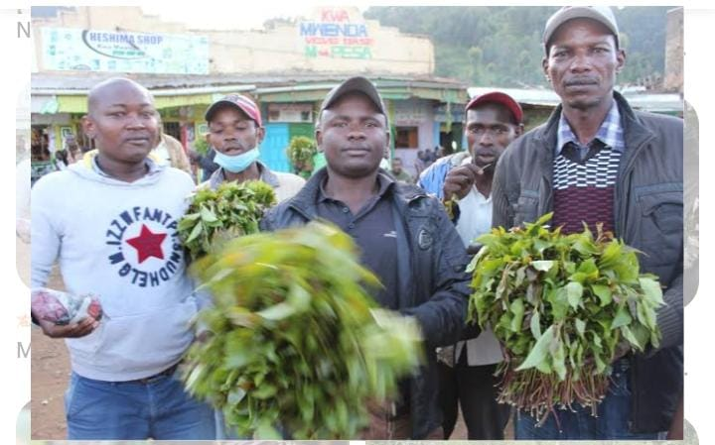

However, efforts to control khat consumption have often been met with resistance from communities where it holds cultural and social significance, highlighting the tension between public health imperatives and respect for cultural practices.

1. Tobacco

While tobacco use has historically been lower in Africa compared to other regions, it has been steadily increasing in recent years, driven by factors such as aggressive marketing by tobacco companies, changing social norms, and economic development. In Kenya, tobacco abuse is a pressing issue that requires comprehensive strategies to address its multifaceted impacts. According to the Kenya National Adult Tobacco Survey, conducted in 2014, approximately 2.5 million adults in Kenya (11.6% of the population) were current tobacco users. This includes both smokers and users of smokeless tobacco products. Among youth aged 13-15 years, the Global Youth Tobacco Survey found that 11.1% reported currently using tobacco products.



*Consumed tobacco brands in Kenya*



While cigarette smoking is the most prevalent form of tobacco consumption, the emergence of alternative products like Velo presents new challenges for tobacco control efforts. One of the key concerns surrounding Velo and similar smokeless tobacco products is their potential to attract new users, including youth and non-smokers, due to their discreet nature and appealing flavors. Flavored tobacco products have been shown to be particularly attractive to young people, leading to worries about increased initiation and addiction among this demographic.

**3. Alcohol**

One of the primary factors contributing to alcohol abuse among Kenyan youth is easy accessibility. Alcohol is readily available and affordable, with a wide range of alcoholic beverages sold in bars, shops, and informal outlets across the country. Weak enforcement of age restrictions on alcohol sales and lax regulation of alcohol marketing contribute to underage drinking and initiation into alcohol use at an early age.



*Fully packed night club in Kenya*

Illicit beers, also known as chang'aa, busaa, or kumi kumi, are typically homemade or informally produced alcoholic beverages that bypass regulatory oversight and quality control measures. These illicit brews often contain high levels of methanol and other harmful substances, making them hazardous to health leading to death.



*Recent illicit brew case*

1. **Bhang**

Data from a NACADA survey reveals that 518,807 Kenyans aged 15–65 are currently using cannabis, translating to a national prevalence rate of 1.9 per cent. The report dubbed ‘Status of Drugs and Substance Use (DSU) in Kenya, 2022’ says that of this figure, 475,770 are male while 43,037 are female. It showed that a total of 193,430 youth aged 15–24 years (one in every 37) were currently using cannabis, translating to a 2.7 per cent prevalence. The data shows that overall, 234,855 Kenyans aged 15–65 years, or one in every 111, are addicted to cannabis and exhibit severe substance use disorders. Use of this drug is common among Campus students.



*Police raiding a bhang farm*

**Prevention and control of drug abuse**

1. **Education and awareness**

Implement evidence-based drug education programs in schools and communities to provide accurate information about the risks and consequences of drug abuse. Moreover, media campaigns and public awareness initiatives to raise awareness about the dangers of drug abuse and reduce stigma associated with addiction.

1. **Community involvement**

Engaging communities, families, and local organizations in drug prevention efforts through grassroots initiatives, support groups, and community outreach programs.

1. **Legislation**

Investing in drug law enforcement efforts to disrupt drug supply chains, dismantle trafficking networks, and reduce the availability of illicit substances.

1. **International cooperation**

Fostering international cooperation and collaboration to combat drug trafficking, transnational organized crime, and cross-border drug smuggling.

**CONCLUSION**

In a nutshell, tackling drug misuse demands a comprehensive strategy that includes collaboration among governments, communities, healthcare professionals, and international organisations. Countries can reduce the adverse consequences of drug usage on public health, safety, and social well-being by putting in place comprehensive prevention, intervention, treatment, and policy measures. Education, outreach efforts, and community engagement are all important prevention strategies for lowering drug use and fostering healthy behaviours among individuals. Furthermore, regulations and legislation have an important role in controlling the manufacturing, distribution, and sale of illegal substances, as well as addressing the socioeconomic determinants that contribute to drug consumption.